**Electrodynamics HW Problems**

**02 – EMF & Inductance**

1. Moving bar in a uniform magnetic field
2. Falling loop in a uniform magnetic field
3. Horse-powered generator
4. Moving loop in magnetic field of a wire
5. Homopolar generator
6. Eddy current brake
7. Moving loop in a time-varying field
8. Conducting disk in a time-varying field
9. Magnetohydrodynamic generator
10. AC generator
11. Rotor generator
12. Voltage measurements near a solenoid
13. Conducting ‘tethers’ in space
14. B-field and self-inductance of a toroid
15. Loop around a solenoid
16. Jumping ring
17. Mutual inductance of concentric loops
18. Iron-core transformer
19. Self-inductance of a coax cable
20. Force on a permeable rod in a solenoid
21. Force for a compressible solenoid
22. Kinetic energy versus magnetic energy
23. EMF devices, energy storage and conversion

**2.01. Moving bar in a uniform magnetic field** [Kinney SP11]

A metal bar with mass *m* is sliding without friction on two parallel conducting rails a distance *l* apart, as shown below. The circuit of rails plus bar is completed through a resistor *R*. The bar, rails and resistor are in a region of space with uniform magnetic field **B** pointing out of the page. At a given time *t* = 0, the bar is moving to the right with speed *v0*.

**(a)** Find the EMF in the circuit using the Lorentz force law, showing the contribution of each piece of the circuit.

**(b)** Calculate the EMF in the circuit using the flux rule. Does it agree with your answer to part (a)? If not, why not?

**(c)** Find the magnitude and direction of the current through the resistor using the EMF from part (b). You can ignore any effects of self-inductance.

**(d)** Determine the motion of the bar after *t* = 0, that is, find an expression for *v(t)*. Does your answer make sense? If you can test your answer using energy conservation, do so. If not, explain why not.

R

v0

l

B(out)

m

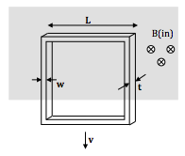**2.02. Falling loop in uniform magnetic field** [Dubson SP12]

A square metal loop is released from rest and starts falling straight down. The loop is between the poles of a magnet with uniform B field, and initially, the top of the loop is inside the field and the bottom of the loop is outside the field. The metal has mass density rm and electrical resistivity r. The loop has edge length L, and is made of a rectangular wire with transverse dimensions *w* and *t*.

**(a)** What is the EMF around the loop in terms of the downward speed v of the loop? Assume the loop reaches terminal velocity before it passes entirely outside the field, and derive an expression for the terminal speed of the loop.

**(b)** Show that the rate at which thermal energy is generated in the metal (Pthermal) is equal to the rate at which gravity does work on the loop (Pgrav). They must be equal, by conservation of energy.

**(c)** At *t* = 0, the loop starts at rest. Use Fnet = ma to write down a differential equation for the speed v of the loop.

**(d)** Solve for the speed v as a function of time. You should find that the speed approaches the terminal speed exponentially. What the time constant for this exponential motion? If the metal is aluminum, what is the value of the time constant? (Do the values of L, w, t matter?)

**2.03. Horse-powered generator** [Munsat FA10]

Farmer Tobin, frustrated by the high cost of electricity, decides to power his extra-large-screen television set by using a home-built generator. The generator is made up of two large conductors coming out of the house, connected to a large sliding rail pulled by his two horses, as shown below. It just so happens that there is a uniform magnetic field of 0.8 Tesla coming out of the ground through the loop. The TV acts effectively like a 9.6 Ω resistor in the circuit, and the friction between the moving parts is negligible.

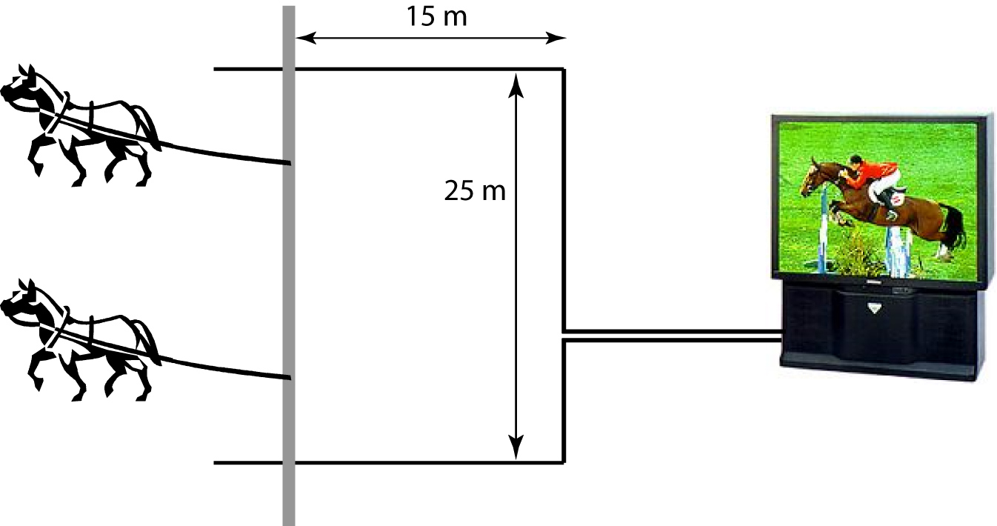

**(a)** How fast do the horses have to pull the rail to produce a D.C. voltage of 120 across the leads to the TV?

**(b)** What is the force on the sliding rail?

**(c)** How much power is expended by the horses?

**(d)** How much electrical power does the TV use?

**2.04. Moving loop in magnetic field of a wire** [Dubson SP12, Pollock FA11]

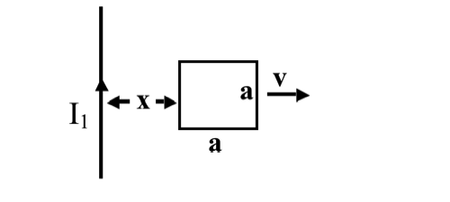

A long wire carries a steady current I1. Nearby to the long wire is a square loop of wire (side length *a*) with resistance *R*. You apply a force on the loop away from or toward the wire so that the loop maintains a constant velocity **v**.

[*Ignore any possible "self inductance" effects in this problem*, *i.e., assume the magnetic field produced by current in the loop is small compared to the field produced by the wire.*]

**(a)** At the moment shown (when the left edge is at a distance "*x*" away from the wire), find:

i) the magnetic flux through the loop.   
ii) the EMF around the loop.   
iii) the magnitude of the current circulating around the loop.   
 (If **v** is to the right, as shown, which way does this current flow?)   
iv) the power dissipated in the loop.

**(b)** Determine the magnetic force on the loop and the power you need to supply to keep the loop moving at a constant velocity, as a function of position *x*. Show that this power is always positive, independent of the direction you push the loop. Explicitly compare your result here to the result from part (a-iv): does the result make sense?

**(c)** Qualitatively, what in the above parts would change if the velocity **v** were parallel to the current I1 instead of perpendicular?

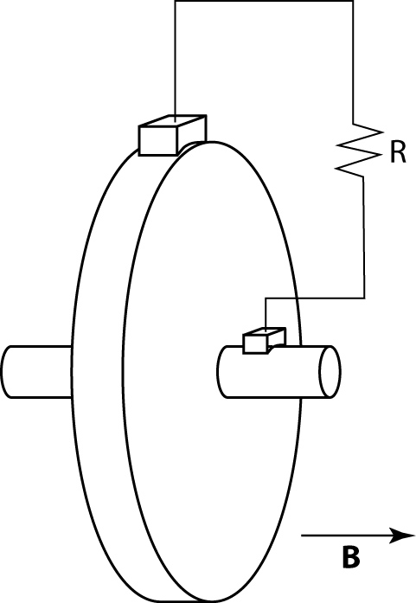**2.05. Homopolar generator** [Munsat FA10]

Michael Faraday came up with a relatively simple DC generator called a homopolar generator. A conducting wheel of radius *R* rotates with angular velocity *ω* in a uniform B-field oriented along the wheel axis. Sliding contacts make an electrical connection between the center of the wheel and the edge, as shown, and an EMF is induced across a load resistance *R*.

**(a)** Show that the induced EMF is given by .

**(b)** How fast would a 1 m diameter generator in a 0.1 Tesla magnetic field have to rotate to produce an EMF of 120 V?

**2.06. Eddy current brake** [Munsat FA10]

An electromagnetic “eddy current brake” consists of a solid spinning wheel of conductivity σ and thickness *d*. A uniform field *B*0 is applied perpendicular to the surface of the wheel over a small area *a* located a distance *ρ* from the axis.

**(a)** Show that the torque on this disk is given approximately by .

**(b)** Estimate how high *B*0 should be for this kind of brake to be functional as a car brake, given a magnet size of 20 cm2 per brake.

**2.07. Moving loop in a time-varying field** [Dubson SP12]

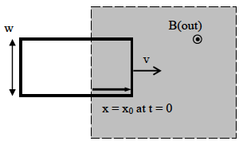

A rectangular loop of metal wire, of width *w*, moving with constant speed v, is entering a region of uniform B-field. The B-field is out of the page and is increasing at a constant rate , where B0 and α are positive constants. At *t* = 0, the right edge of the loop is a distance *x*0 into the field, as shown. Note that the EMF around the loop has two different causes: the motion of the loop and the changing of the B-field.

**(a)** Derive an expression for the flux through the loop as a function of time, while the loop is entering the field.

**(b)** Derive an expression for the magnitude of the EMF around the loop as a function of time, while the loop is entering the field. Check that your answer makes sense by considering the two cases v = 0 and α = 0. Explain how these limits give answers you expect.

**(c)** Is the induced current in the loop clockwise, counterclockwise, or impossible to determine without knowing the values of v and a? Explain.

**2.08. Conducting disk in a time-varying field** [Dubson SP12, Pollock FA11]

A conducting disk with radius *a*, height *h* << *a*, and conductivity σ is immersed in a time varying but spatially uniform magnetic field parallel to its axis: 

**(a)** Ignoring the effects of any induced magnetic fields, find the induced electric field  and current density  in the disk. Sketch the current distribution.

**(b)** If the power dissipated in a resistor is , show that the power dissipated **per** **unit** **volume** is . Calculate the total power dissipated in the disk at time *t*, and the average power dissipated per cycle of the field.

***Extra credit*:** If the disk in question were roughly the size of the solid base of a typical frying pan, and the frequency was 10 kHz, what approximate scale for B0 would you need to significantly heat up the pan (say, 1000 watts of power). Does this seem feasible? Now, use the current distribution in part (a) above to determine the induced magnetic field at the center of the pan. For what range of parameters is the induced magnetic field small compared to the applied field? **Note:** **For** **real** **induction** **stoves,** **it** **turns** **out** **that** **the** **induced** **magnetic** **field** **is** **NOT** **small** **compared** **to** **the** **applied** **field,** **so** **this** **calculation** **of** E **and** B **(which** **ignored** **the** **induced** **field)** **is** **not** **quantitatively** **correct.** **Induction** **stoves** **work** **just** **fine!** **We** **need** **to** **learn** **some** **more** **physics** **to** **improve** **this** **calculation.**

**2.09. Magnetohydrodynamic (MHD) Generator** [Munsat FA10]

Consider a rectangular pipe with dimensions (Δ*x,* Δ*y,* Δ*z*), with insulating sidewalls (located at ±Δ*x*/2) and conducting top/bottom walls (located at ±Δ*y*/2). Ionized, conducting plasma flows through the pipe with velocity , and a uniform magnetic field is imposed: .

**(a)** What is the potential between the top and bottom walls of the pipe?

**(b)** If the top and bottom walls are connected by a load resistance *R*, and the plasma has conductivity σ, how much current is driven through the load?

**2.10. AC generator** [Dubson SP12, Pollock FA11, Munsat FA10]



A square loop with side *w* is mounted on a horizontal axis and rotates with a steady frequency *f* (rotations/sec.) A uniform magnetic field ***B*** points left to right between the two pole faces. The figure shows the configuration at time *t* = 0.

**(a)** Find the EMF around this loop as a function of time for this (AC) generator.

**(b)** If the output is connected to a load resistance *R*, calculate the instantaneous and average power dissipated in the resistor. Compare your results to the mechanical power needed to turn the loop.

**(c)** If the rotation rate is 60 Hz, the loop has area 0.01m2, and the B-field is 0.01T, about how many turns of wire would you need to produce a standard 120 V (RMS) output?

*A common variant is to hold the loop fixed (the stator) and rotate an electromagnet coil (the rotor) around the stator. This configuration is commonly called an alternator.*

**2.11. Rotor generator** [Kinney SP11] – A simple generator consists of a metal bar of rectangular cross section, the rotor, which swings through a region of uniform magnetic field **B**, as shown in the figure. The rotor has length *L* and cross sectional area *A* and is attached to a crankshaft at one end; the other end slides on a circular frictionless conducting track. The track is connected electrically to the load resistance *R*, which is then connected to the crankshaft to complete the circuit. The track and load resistor are fixed (not rotating with the rotor).

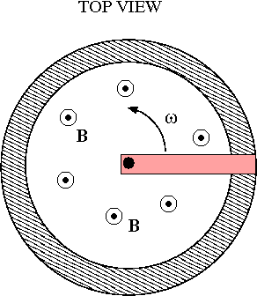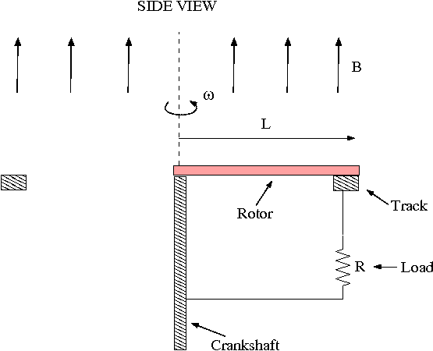

**(a)** The rotor is driven mechanically so that it has an angular velocity of ω; calculate the electromotive force (EMF) generated. Indicate the direction current will flow when the circuit is connected.

**(b)** Assuming no friction, what is the torque (about the crankshaft) needed to drive the rotor at angular velocity ω when the circuit with load resistor *R* is connected?

**2.12. Voltage measurements near a solenoid**

[Pollock FA11, Kinney SP11, Munsat FA10]

Consider the electrical circuit shown below. There is an infinitely long solenoid (shaded, shown end-on in the figure). The current around that solenoid circulates CW and is increasing with time, producing a flux (into the page) that is linear in time: .

Surrounding that solenoid are some "ideal" wires and two resistors, as shown, with ideal voltmeters (that means they have *very* high internal resistance, and thus negligible current flows through them) connected as shown. (The probes of voltmeter V1 are directly across resistor R1, and those of V2 are across R2.)

**(a)** What do the two voltmeters read? (Including signs) How can it be that the two readings are different? (Look carefully - shouldn't points *a* and *b* have a unique voltage drop between them? If not... why not?)

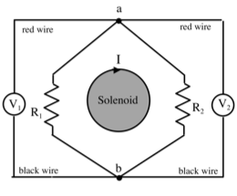

**(b)** Consider two of those circuits connected as shown in the figure below.   
The solenoids are identical, both with the same cross sectional area (= 0.1 m2), and the magnitude of the magnetic field inside both is equal and increasing at a constant rate (= 1 T/s). (However, note the *direction* of the current is opposite in the two solenoids, so the B-fields are in fact increasing in opposite directions.)   
The resistors have the values shown. Determine the current passing through each resistor. (Magnitude and direction)

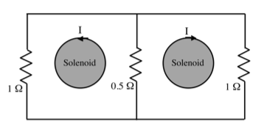

**2.13. Conducting ‘tethers’ in space** [Rogers SP09]

Tethers can use the velocity of a spacecraft through the Earth’s magnetic field to generate electrical power. Alternatively, electrical currents pushed through the tether might be used to change the spacecraft velocity for either propulsion or for braking and reentry. Several ‘space tether’ experiments have been flown, to investigate the possible use if Faraday’s law for power generation and/or propulsion. Examples are the 1996 joint US/Italy effort to deploy a 20 km tether from one of the space shuttles to generate power, or the European Space Agency’s Young Engineers Satellites (YES2) experiment that deployed a 31 km tether as a means of reentry for a small payload dropped from a Russian Foton spacecraft.

**(a)** What is a typical low-Earth orbital velocity? To be definite, assume an orbit 200 miles above the surface of the Earth. Assuming that you increase the velocity, do you go to a higher or lower orbital altitude?

**(b)** The Earth has a magnetic field that is approximately described by an ideal magnetic dipole. This field apparently arises from circulating charge currents within the convective parts of the Earth’s mantle. These flows are directly related to the flows causing plate tectonics. Fascinating stuff… OK, so look up a typical size of the Earth’s magnetic field at some location on the Earth’s surface, use it along with the dipole field model to estimate the Earth’s magnetic dipole moment magnitude, *m*. Using some information about the size of the Earth’s core, mantle, etc. Estimate the electric current that must be flowing to produce this magnetic moment.

**(c)** Now combine the typical orbital velocity and the typical magnetic field magnitude and direction to calculate the motional EMF that could be generated along a 20 km conductive cable. Assuming the orbit is around the magnetic equator, in which direction relative to the orbital velocity direction would you deploy the cable to create the largest EMF?

**(d)** Lovely, so now you have a cable stretched out and it has some EMF generated along its length. However, to generate useful POWER, the product of current and voltage, you need to have a closed circuit to allow current to flow. Perhaps you could stretch a second cable out from your spacecraft to touch the first cable and to complete the circuit? Explain why that’s not going to work.

**(e)** In fact, the circuit is completed by the ionized plasma that surrounds the Earth, the so-called ionosphere. In the shuttle tether, there was an insulating, roughly 1cm diameter nylon cable surrounded by conductive copper braid of 3 mm thickness, all wrapped in an insulating Kevlar layer. Data taken during the experiment suggested that the ionosphere was ‘somewhat less conductive’ than the copper braid. Make life simple by assuming that the ionosphere conducted in a cylindrical pipe 20 km long and with cross sectional area equal to the areal size of the space shuttle (roughly 200 square meters) estimate the plasma conductivity. What additional information would you need to know to estimate the density of charged particles in the plasma?

**2.14. B-field and self-inductance of a toroid** [Dubson SP12]

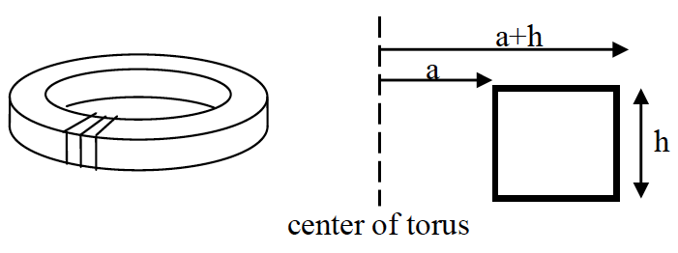

Consider a toroidal coil of N turns of wire and square cross-section, with height h, inner radius a, and outer radius (*a* + *h*), as shown. The wire carries a current *I*.

**(a)** Compute the B-field everywhere inside the torus. (Outside the torus the field is zero. Can you convince yourself of this?)

**(b)** Derive an expression for the self-inductance of the torus.

**(c)** You work at the company that manufactures these toroidal inductors. The dimensions *a* and *h* are fixed by the customer's specifications, and the mass of the copper wire you can use is fixed by your budget. Your boss wants to know if changing the diameter of the wire used will increase the ratio of inductance-to-resistance of the torus (*L*/*R*). Since the volume of the wire is fixed, you can go with more turns of thinner wire, or fewer turns of thicker wire. More turns means higher inductance, but thinner wire means higher resistance.

Does **decreasing** the diameter of the wire used result in larger *L*/*R*, smaller *L*/*R*, or no change in *L*/*R*? (Assume that, whatever wire thickness you choose, the thickness is much smaller than *a*, *b*, or *h*.)

**2.15. Loop around a solenoid**

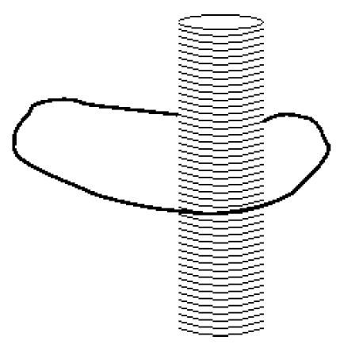[Dubson SP12, Pollock FA11, Kinney SP11, Munsat FA10]

Consider a single loop of wire wrapped around the outside of an infinite solenoid as shown. The solenoid is circular in cross section, of radius *R* and has *N* coils per length *l*, so the coils per length is *n* = *N*/*l*. The single loop is irregular in shape.

**(a)** Find the mutual inductance *M* between the loop and the solenoid.

**(b)** Suppose now that the loop goes around the solenoid twice. Again, find the mutual inductance *M*. How does it compare to the answer from part (a)?

**(c)** Find the *self-inductance per unit length* of the infinite solenoid, all by itself. Now check that the units of your answer work out correctly. Begin by expressing the units of μ0 in terms of henries. [Hint: start with the fact that for a solenoid  and write the units of μ0 in terms of teslas and amps. Qualitatively, how would you expect the self-inductance to change for a finite solenoid? Again, briefly but clearly explain your reasoning.

**2.16. Jumping ring** [Pollock FA11, Munsat FA10]

In class, we saw a demonstration of a “jumping ring”, where we applied an AC voltage (and thus AC current) to a solenoid, and a ring of copper wrapped around the solenoid was launched into the air.

The explanation I gave in class went something like this: “The changing flux caused by the alternating current in the solenoid induces a current in the copper ring. The current in the ring causes a magnetic field which opposes the field from the solenoid, so the ring is forced away from the solenoid.”

Now I’m changing my story. I claim that during some parts of the cycle, the induced current in the ring causes a magnetic field in the *same direction* as the field from the solenoid, thus pulling the ring back on to the solenoid!

**(a)** Show that in the simplest approximation, the time-averaged force on the ring is zero.

**(b)** Show that if there is a small *phase lag* in the response of the ring (due to, say, the self-inductance of the ring), so that its response is slightly delayed with respect to the ideal case, then the time averaged force will be *nonzero*, and directed away from the solenoid.

***Hint:*** *Note that we are not asking you to compute the numerical force on the ring. That would be a significantly harder problem; you would need more information about the details of the setup. We are only asking for you to consider the sign of the answer. Think about the force between two nearby current loops – parallel currents attract, opposite currents repel, with a force directly proportional to the amount of current.*

**2.17. Mutual inductance of concentric loops** [Munsat FA10, Rey SP10]

Two circular loops of wire are arranged so that they lie in the same plane and are concentric. One loop, of radius *a* is much smaller than the other, which has radius *b*, i.e. .

If the small loop is driven with a time varying current , derive an approximate formula for the induced EMF in the large loop. Be sure to state the approximations or assumptions that you make in your derivation.

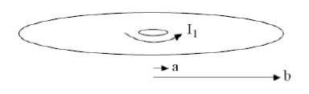

**2.18. Iron-core transformer** [Kinney SP11]

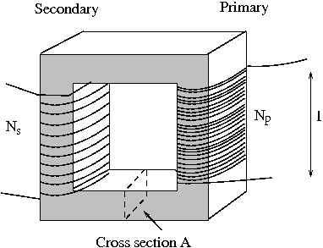The simplest way to make a compact transformer is to use iron to “trap” the magnetic flux so that it can be “channeled” from one circuit to another in a mechanically stable and simple way. One common design uses a square frame of iron (permeability μ), shown below. On the “input” side (the primary) a wire is wrapped around one side of the frame *Np* times; one the other side (the secondary) a wire is wrapped around the frame *Ns* times. The coils wrap around the side in such a way that positive flux in the primary side corresponds to positive flux in the secondary.

**(a)** Assuming that you can treat the primary and secondary sides as infinite solenoids (actually a much better approximation because of the iron), find the mutual inductance between the primary and secondary coils. Take the cross sectional area of the iron sides to be *A* and the length of each coil to be *l*.

**(b)** Again, treating the coils like infinite solenoids, find the self-inductance of each coil. Compare the results to your answer to part (a).

**(c)** Given that the current *Ip* in the primary is changing with time, find the ratio of the EMF in the primary side ε1 to the EMF induced in the secondary side ε2.

**2.19. Self-inductance of a coax cable** [Pollock FA11, Kinney SP11]

Consider a standard coax cable as an “infinite” length wire of radius *a* surrounded by a thin conducting cylinder, coaxial with the wire, with inner radius *b* and outer radius *c*. Assume *a << b* and (*c* – *b*) *<< b* (thin shell and wire).

A current *I(t)* flows along the wire and a corresponding current *I(t)* flows in the opposite direction on the outer cylinder. Assume that we have the quasi-static situation in which the currents are identical in magnitude at each moment in time, and the changes in current are sufficiently slow.

**(a)** Find the self-inductance per length of the cable by considering the change in flux as *I* is changed. Ignore the small amount of flux within the conductors themselves.

**(b)** Now find the self-inductance per length by considering the magnetic energy W stored per length of cable and relating that to the energy W stored in an inductor L by current *I*. Does your answer agree with that from part (a)?

**2.20. Force on a permeable rod in a solenoid** [Munsat FA10]

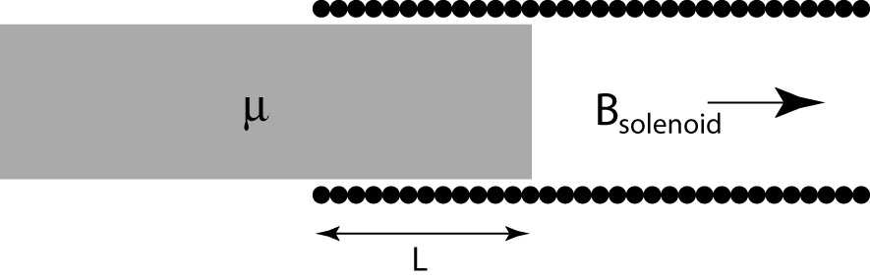A long cylindrical rod (permeability , length *L0*, radius *R* << *L0*) is partially inserted into a long solenoid (length *L1*, radius *R* << *L1*, turn density *n*, fixed current *I0*).

**(a)** How large is the force on the rod?

**(b)** Is the rod pulled into or pushed out of the solenoid? Does it matter whether the material is paramagnetic or diamagnetic?

(Hint: Start by considering how much energy is contained in the magnetic fields.)

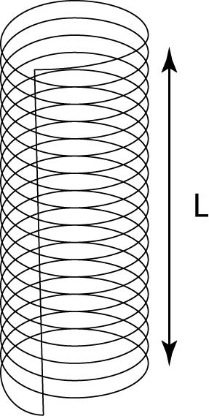

**2.21. Force for a compressible solenoid** [Munsat FA10]

Consider the long solenoid shown at right, made up of *N* turns distributed over length *L* and diameter 2*R*, carrying fixed current *I0*.

**(a)** Show that the expansion/compression force exerted by this coil is

.

Does this force act to expand or compress the coil?

**(b)** Describe what corrections are required to make the expression in part (a) exact.

**2.22. Kinetic energy versus magnetic energy** [Dubson SP12]

We have shown that the energy stored in an inductor is , which is the energy stored in the magnetic field. This ignores the kinetic energy of the conduction electrons, due to their drift velocity.

**(a)** Derive an expression for the ratio of kinetic to magnetic energies in an inductor:



Assume the inductor is a long, single-layer solenoid of radius *R*, made of wire of radius *r*. Assume also that there is one conduction electron per atom, and the volume per atom is *d*3 (*d* is roughly the distance between atoms). If you simplify the ratio as much as possible, you will find that it depends only on *R*, *r*, *d*, and fundamental constants, such as the mass and charge of the electron. All other factors such as current *I*, number or turns *N*, etc. cancel out.

**Hint:** It may help to notice that the length of the solenoid is given by  and the length of the wire in the solenoid is given by 

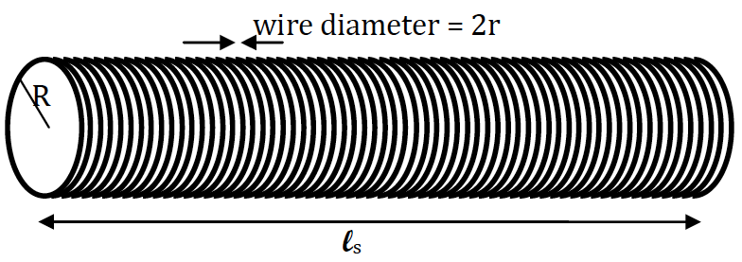

**(b)** Compute the value of this ratio from part (a), using , *r* = 0.5 mm, and *R* = 1 cm. Are we justified in ignoring the KE of the electrons when computing the energy in a solenoid?

**2.23. EMF devices, energy storage and conversion** [Rogers SP09]

**(a)** A typical flashlight battery ‘D-cell’ is designed to provide an EMF of 1.5 volts and has an charge rating of around 12 amp hours (yup, it’s a strange mix of units), meaning that it could deliver 1 amp for 12 hours or any other product of current and time with the same product. How many coulombs of charge can be delivered through a load resistor, and how much energy is stored in the battery?

**(b)** Suppose that you want to have a capacitor that has the same 1.5 volt as a battery, what capacitance is required to be able to store the same energy as the battery? In no more than a couple of sentences and perhaps equations, explain whether you think that it’s reasonable to just replace batteries with capacitors.

**(c)** While it’s hard to store as much energy in a capacitor as you can store in a battery of similar size, capacitors can deliver their energy very quickly. Therefore, they can provide more POWER, but for a shorter period. Similarly, while it may take several hours to charge a battery (because the chemical reactions involve diffusion of chemical species, which is slow), you can charge a capacitor at any rate slow enough that you don’t melt the electrical leads. For example, hybrid vehicles use regenerative brakes, where the mechanical energy of the vehicle is converted to electrical energy and is stored in ‘ultracapacitors’ (see below). Assume a 1000 kg hybrid moving at an initial speed of 10 m/s. How much electrical power are you dealing with on average if you want to convert the energy to electrical energy and stop the car in 5 seconds?

**(d)** ‘Ultracapacitors’ are a type of capacitor with electrodes made typically from packed activated charcoal, to produce really large surface area electrodes. In addition, the packed powder is filled with a chemical compound that conducts electricity rather well, but not across the interface with carbon. The end result is a charged capacitor of large area and nanometer plate spacing. Go to the website for Maxwell Technologies, and find an ultracapacitor product that would satisfy the requirements of vehicle braking that you worked out in part (c) above.

**(e)** The generators at the Hoover Dam are rated for 2 Gigawatts. They are driven by the total flow of the Colorado River (roughly 100,000 cubic feet per second) dropping through 450 vertical feet. Are these numbers consistent?